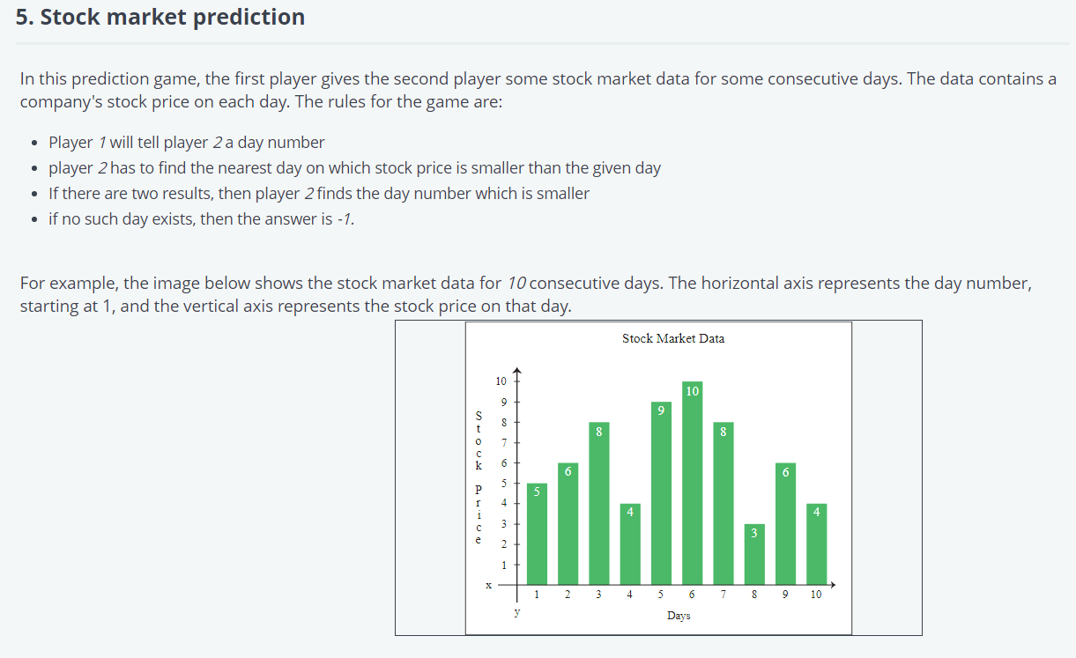

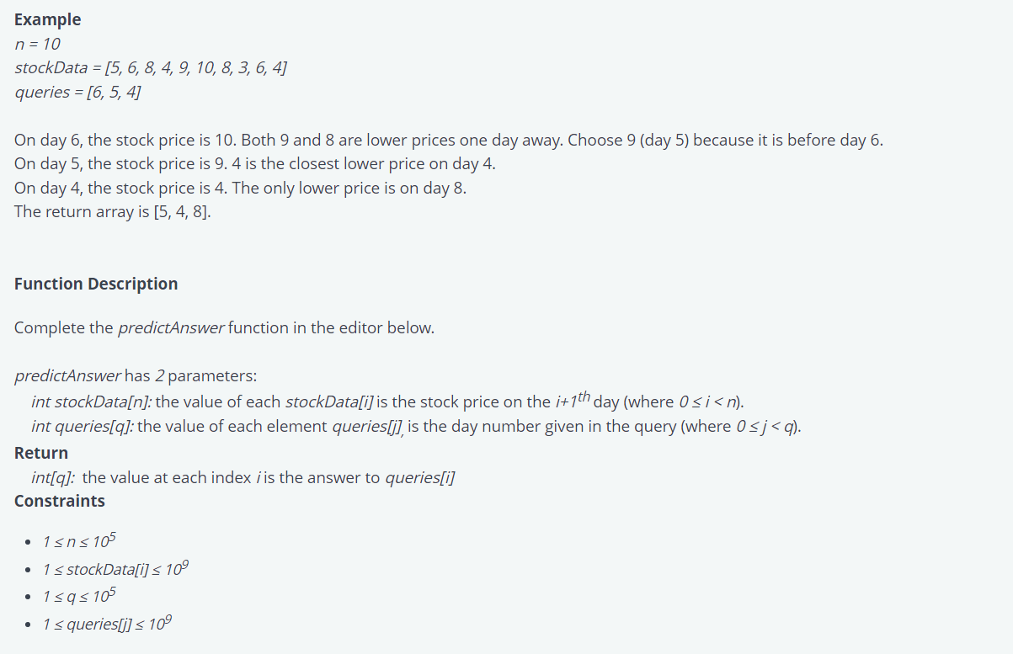

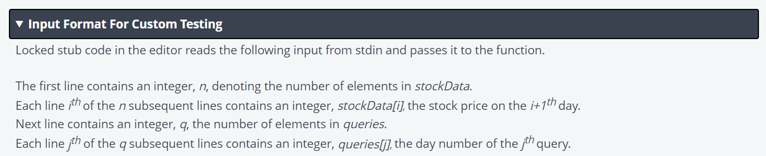

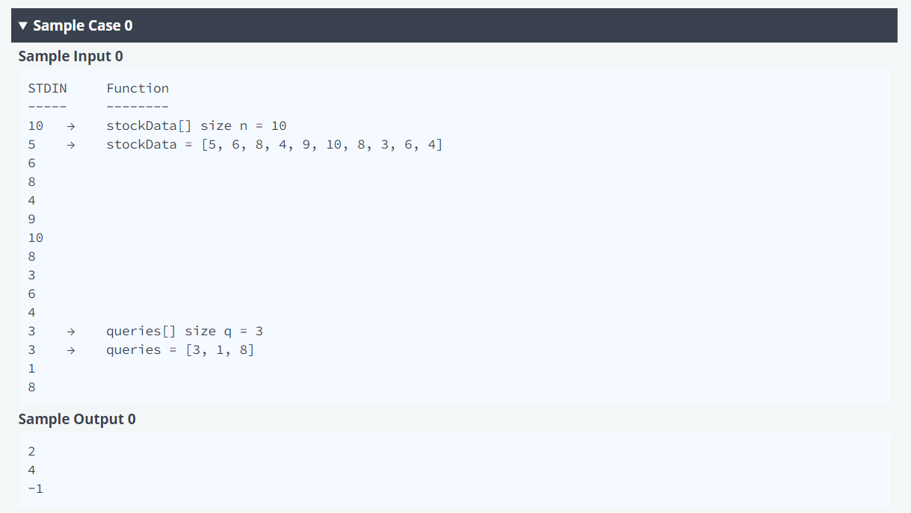

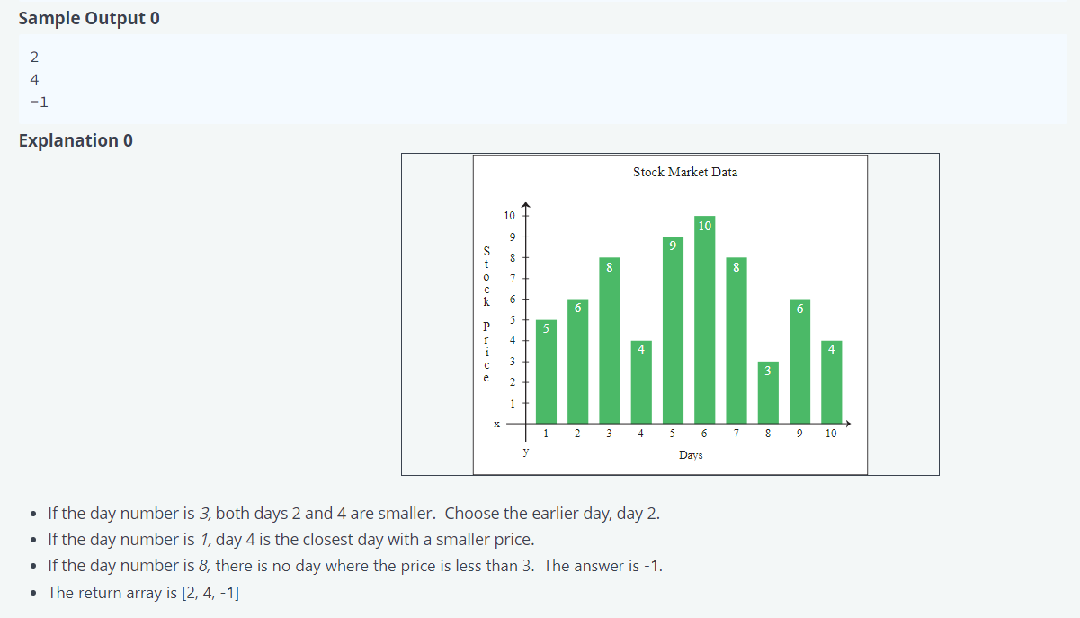

5. Stock market prediction  
In this prediction game, first player gives the second player some stock market data for some consecutive days The data contains a  
company's stock price on each day. The rules for the game are:  
• Player wil tell player 2 a day n u mber  
player 2 has to find the nearest day Which Stock price is smaller than the given day  
• If there are two results. then player 2 finds the day number is smaller  
• if no day then -  
the image the Stock market data for 'Oconsecutivedays. The horizontal axis represents the day number,  
Starting at 1 , and the axis price on that day.

Example  
stm-kData-(5, 10, 3, 4]  
queries ; 5 4)  
On day 6, the stock price is 10. 80th 9 and 8 are lower prices one day away. Choose 9 (day 5) because it is before day 6.  
On day S. the stock price is 9_ 4 is the closest price on day  
On day 4. the stock price is 4. The only price is on day 8.  
The return array is (S, 4,  
Function Description  
Complete the predictAnswer function in the editor  
predictAnswer has 2 parameters:  
int the value Of each StOCkData(iJiS the Stock price on the i • day (where O S i  
int queriesrq}: the value Of each element queriesW. iS the day number given in the query (where O Sj <  
int!q/: the value at each index i is the answer to queries(iJ  
Constraints  
• stockDatd(iJ

Input Format For Custom Testing  
Locked stub code in the editor reads the follcming input from stdin and passes it to the function.  
The first line contains an integer. n denoting the number of elements in stockData.  
Each line 'h of the n subsequent lines contains an integer, stockData{i1 the stock price on the i•lthday.  
Next line contains an integer. q the number of elements in queries,  
Each line fh of the q subsequent lines contains an integer, queries&l the day number of the p query.